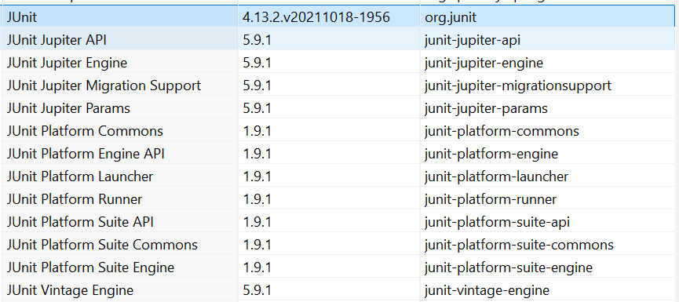

,"com.aventstack.extentreports.cucumber.adapter.extentCucumberAdapter:"

